**Interview Results**

Our first interview with the sponsor was very successful. The sponsor, as well as each team member, was prepared with questions to ask, and we built a great relationship based on that meeting. The main takeaways from the interview were the specified description of their current system, user requirements for the new system, and a communication plan we agreed upon. With a solid foundation, we started our system analysis.

**User Requirements**

During the initial meeting with the sponsor, we identified the user requirements. The system is designed for the school theater. Their requirement is to have a database to keep track of inventory logistics. Inventory items will include lightings, sounds, costumes, and stage settings. Their key questions sponsor have are to figure out “What do we have?” and “Who has what?”.

**Requirement Model Diagram**

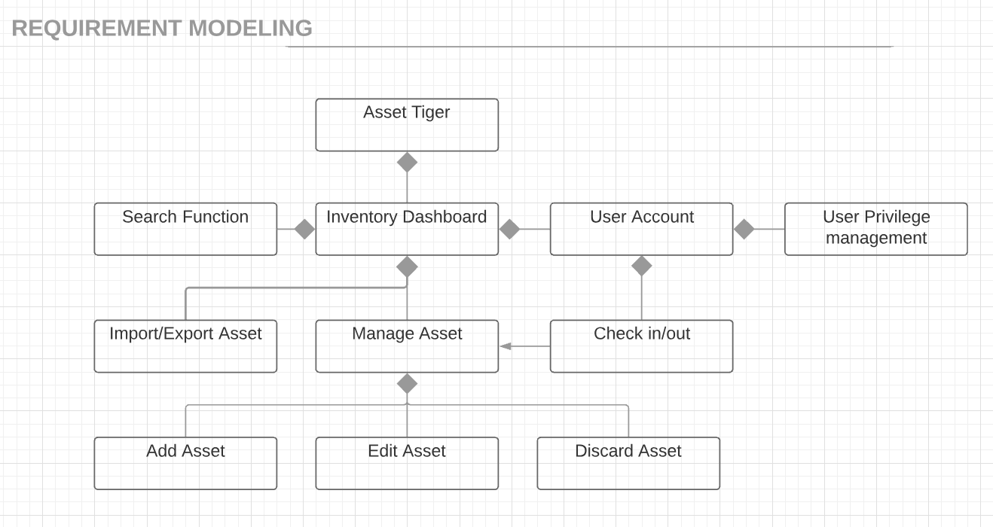

This model diagram represents all of the user requirements that our Project Sponsor specified for the application. These functions serve the purpose of the application.

**Current Process**

There was not a technical system in place. Items are placed in storage room by heuristics, and staff retrieve items on request, keeping a record on paper.

**Identify what new system does**

The new system is an online application that is compatible on both desktop and mobile. The system’s functionalities include: creating new records, editing records, managing employees and recording contact info for parents and students, modifying table columns, reserve/check-out items, backing and restoring the database, and a tool for reporting.

**Fact Finding**

The showrunner will reserve the assets that they require using the reservation system, then they check those items out to the parents of a child in a Theater production. Once the production is complete, the parent returns the asset to the showrunner and the showrunner makes sure that everything is put back into the storage in a proper manner. Once the item is reserved, it can be checked out on the reservation date. Once it is checked out, the status of the item must be updated to “checked out”. The parents must return to item to a staff member who can then place the item back into its’ designated location. Once the item is returned and in place, the item status is updated to “available.”

**Build business model - Use Case Diagram**

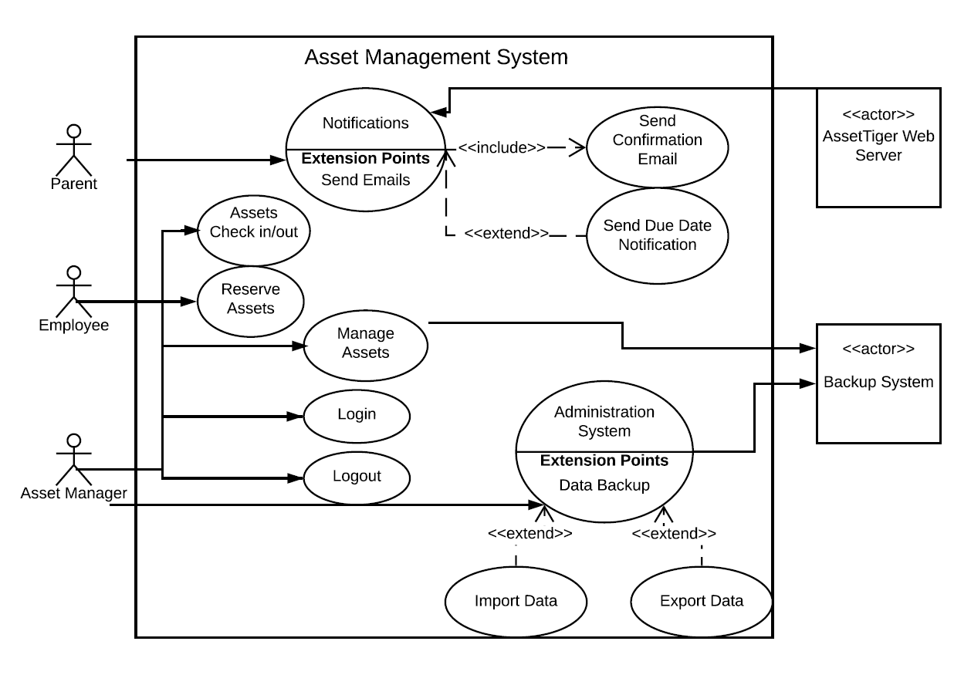

This diagram represents the process that parents, employees, and the asset manager go through for the regular use case of booking inventories.

**Data and Process Model - Data Flow Diagram**

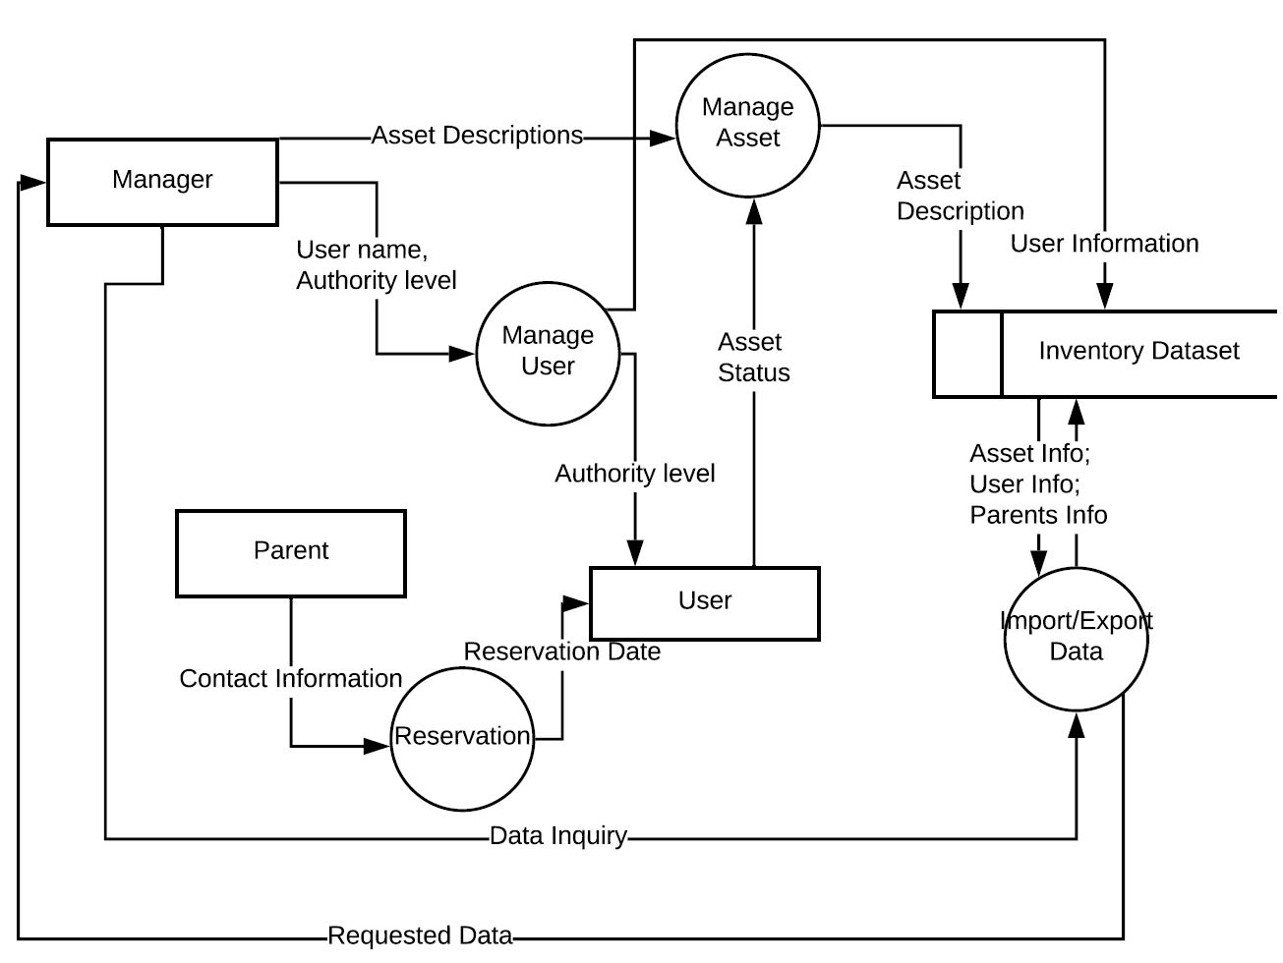

**Organization Chart**

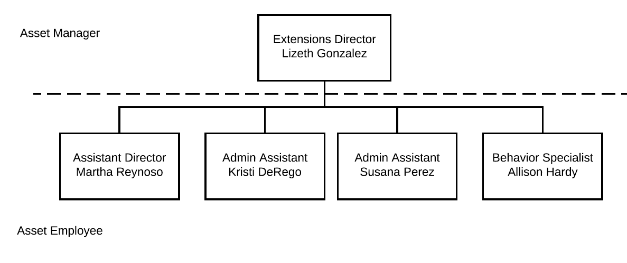

This chart represents the hierarchy of workers in the Extensions program at CUSD.

**Development Strategies: in house using SaaS**

Build in house: We originally tried to build our own database in order to meet the project sponsor’s specifications while eliminating the cost. Liz specified that we must create an inventory database with a reservation system that had the ability to add and delete items, create and edit a record, manager users and people, modify table columns, list the current status of an item, and make a backup of the database that is exportable to Microsoft Excel that is compatible with both desktop and mobile. After pondering this process, we realized that it would take far too long to create an application.

In House using SaaS - Snipe IT: Snipe IT was a more viable option since it allowed us to combine it with WordPress plugins. These plugins were premade inventory databases that were lacking the ability to add and delete items, create and edit a record, manager users and people, modify table columns, list the current status of an item, and make a backup of the database that is exportable to Microsoft Excel

In House using SaaS - Asset Tiger: This was a premade paid application that met all the requirements of the project sponsor and was within the project budget. We presented this option to the project sponsor, who was enthused to see the application in use and had no problem with the yearly cost of $100.

**Analyze Cost and Benefits (TCO)**

In the perspectives of the sponsors, the cost of implementing the new system would be bearing the risks carried by the new system, time cost of training staff to learn about the new system, payment of the service, volunteers’ efforts to record items in database, and the time needed to communicate with the project development team.

On the other hand, the benefit of implementing the new system would be to keep clear logistics of each check-in and check-out process, having a reservation function, having an organized list of all inventory items that saves time for maintenance.

**Prototype Solution**

The following two diagrams are our initial system mockup and initial system flow diagram after generating the prototype. They represent the process that occurs every time a user is utilizing the application. The user must go through all steps that are present in the flow diagrams in order to arrive at a solution.

The third one attached is the revised workflow diagram, which is very similar to our final product.

